This is a working draft, not suitable for reading by anyone but the authors.

Tolerant and Flexible Collaboration with the Chorus Distributed Version Control Algorithm
Authors: To be determined
Payap University Linguistic Institute & SIL International

Abstract
Chorus is a set of components and algorithms designed to enable workflows appropriate for language development teams who are geographically distributed. This paper describes the operations which Chorus-based systems need to implement on top of standard Distributed Version Control systems. These operations enable the workflows needed by language teams, including those that maintain a “master” database separate from the incoming submissions of team members. Quite unlike what the raw version control systems support, a system built on top of Chorus can works invisibly for the common cases, even when conflicts occur.

Table of Contents
1) Introduction
6) Conclusion

Introduction
There are at least three factors to consider when enumerating the scenarios the system needs to support. How many people are part of the team? How is the team connected, be it LAN (Local Area Network), Internet, mailed or hand-carried storage, or short-wave radio? However data passes between them, how often will this connection take place?
Considering the workflow of the team, what are the roles each will play? Will they be entering or editing parts of the database in a way that often overlaps? Will someone have a gatekeeper role on a master or gold copy of the data?

Problem
ToDo: describe current situation

Goal

Transparent Partial Merging

Separate, persistent, and up-to-date difference files

Protection of Master branch

Push from Master to team members

Appropriate protection of team members’ data when push from master is older than their edits.

Order of sync’ing should not matter

Fast trivial checkin
Here, a trivial checkin is where a team member synchronizes and there is no new work from other team members available. His latest work is added to the local repositories, where it is essentially a backup and available for other users to sync with, but there isn’t anyone else’s work sitting there that he needs to merge with.

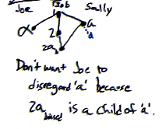

Obstacles

Receding Common Ancestor
A large part of the power of version control systems is their ability to do 3-way-merging. This is a merge which looks not only at, say, Bob’s file and Sally’s, but also the version of the file from which they diverged. So if Sally gets a copy of Bob’s document on Monday, and then they both work on it independently the rest of the week, a 3-way merge will make use of the file as it was when Sally first got it from Bob. This enables the merging program to recognize when Bob deletes something. Without the common ancestor, there would be no way to know if Bob deleted it since Monday, or Sally just added it.
Once two people do an actual full merge, the merged version becomes a new common ancestor, useful for future merges. This new common ancestor is closer (in time and content) to the work going forward, so it is more useful. That is, it is more likely to have an item that is later deleted, so that the deletion can be correctly detected. If we never got new common ancestors, then the one we do have would recede farther and farther in the past, and would become increasingly unhelpful.
Since we don’t want to force our users to actually do complete merges, we don’t naturally get these new common ancestors. One of the challenges of Chorus will be to come up with a common ancestor, on a regular basis, even if the team members don’t actually do complete merges.

Existing Approaches and Related Work
[Khanna] mentions the value of a merge operation which produces a file containing all non-conflicting changes. This is what we call the Least Common Denominator merge.

Scenarios

Single user
ToDo: introduce the concept of version control and how language apps might make use of it for a single user.

Two users, no conflicts
What is a conflict?
ToDo: define conflicts

Tolerant Conflict Handling

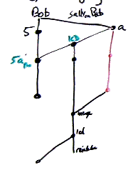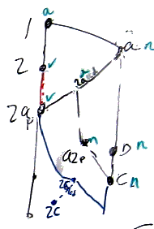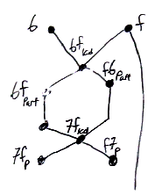

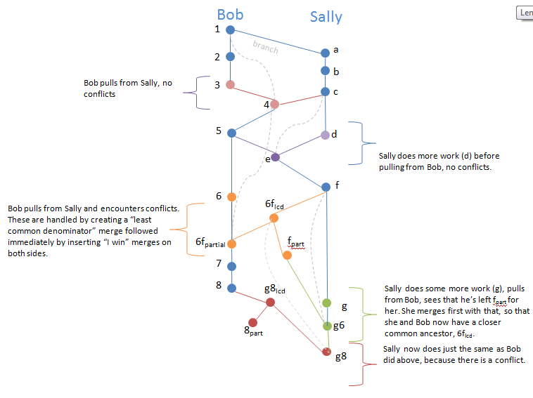

Keeping a Master branch
Idea: A branch may have a settings file that the Chorus system recognizes and reads. This controls its behavior during a sync. To set up a “master” branch, we need to configure that file to say that we never just pull changes in from other files. Rather, the user/comittee will need to use the software application(s) that edit the data in order to pull in the desired changes.
So, once there is an update to the master branch, should satellites treat that differently than peer branches?
**will there be a problem if bob syncs with the master first, then with sally, but sally hasn’t seen the master yet? Could he loose master changes as sally’s edits overwrite them?
Satellites might want to be able to just “start fresh” using the latest master, but this seems undesirable in the some common cases:
- The satellite has some work which is not finished, and thus didn’t make it into the master. This work shouldn’t just be discarded.
- After sending his work off to the master-building process somewhere else, a user keeps working. He doesn’t want to lose that work. One case is where a record was deleted from the master, but meanwhile someone started beefing it up. It should not be deleted from the user.
Master pushes changes that overwrite user unless user has made change since.
Nothing new available from other workers.
Sync before starting work?

Algorithms

New User
- Branch from existing user
- Rename branch to my name

Sync with another repository
- check in my work in my branch, creating a new head, A
- for all heads other than A
  - add the tag "X"
- pull, which will bring in 0 or more new heads
- for each head that is not A & does not have an X tag (i.e. those that just come in)
  - is there a X-tagged equivalent? merge with that first, producing a new, untagged head B. [TODO: what if that has a conflict]
  - Any X-tagged guys can be left as-is, we didn't get anything new for them.
- For each head branch (B) that is not A,
  - Create an O’ = LCD(A, B, O) (non-conflicting changes merge) and commit it to the B branch
  - Create a B’ = PartialMerge(A, B, O) and commit it to the B branch
  - Merge A (our head) with O’, and commit that to the A branch.

Problems:
Does this handle the case where A and B were previously merged in to the same node? Presumably that won’t be tagged as x

Appendix
Notation
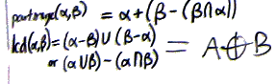

Conclusion

References
[1] www.cis.upenn.edu/~bcpierce/papers/diff3-short.pdf

